Portfolio Comparisons in Con Edison Multi-family Energy Efficiency Program

Prescriptive utility programs can provide low cost solutions to improving energy efficiency in large portfolios in a variety of ways. The Comparison Chart below presents four large portfolios enrolled in the Con Edison Multifamily Energy Efficiency Program that provides free in-unit lighting and water saving devices and incentives for common area gas and electric retrofits. Portfolios 1 and 3 enrolled all their buildings to receive the free in-unit installations. As most building electricity is used in the residential units, this provided subtantial kwh and kw savings at no cost to the owner. Unless the building is master metered or the in-unit electricity is included in the rents, the savings accrue to the tenants. However, the owners may enroll in demand management programs that would provide a financial benefit for these Kw reductions.

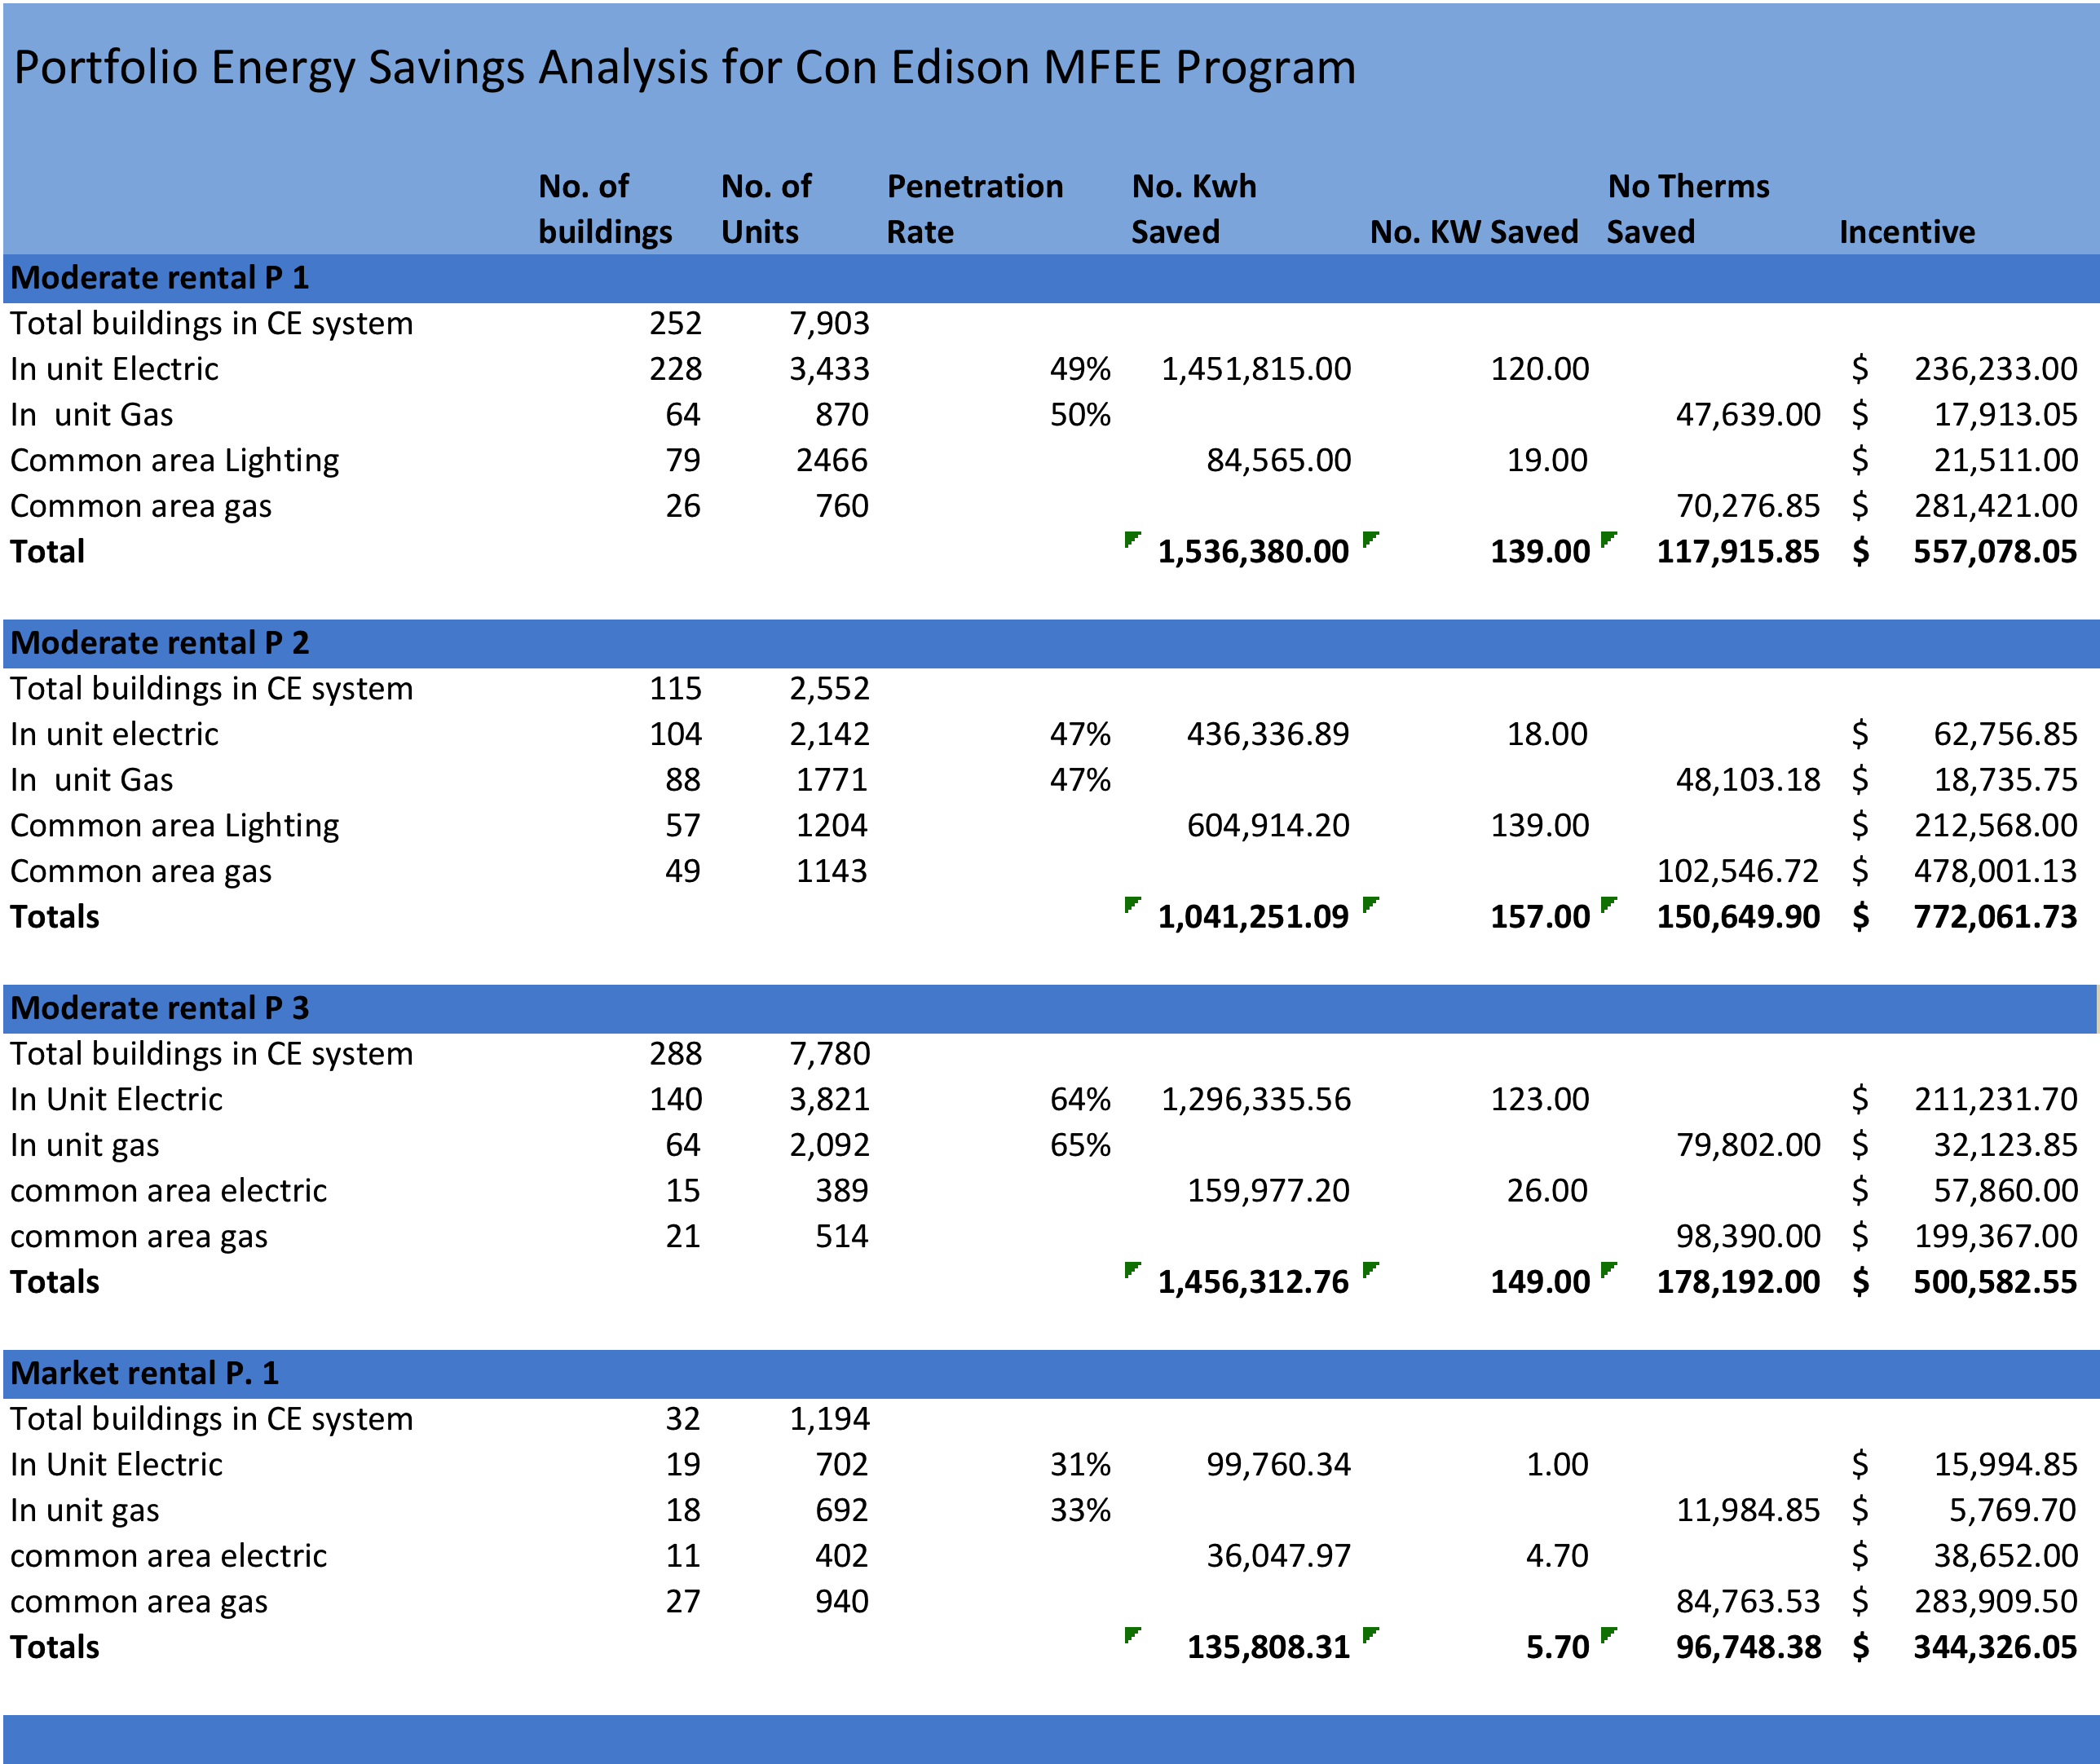
Increasing resident awareness of how they use energy and tools to reduce use is an added benefit from in-unit installations. This is especially useful in coops and condos as informed owners will be more supportive of energy saving projects that reduce maintenance costs.
All clients took advantage of the incentives for gas and electric measures that included: energy management systems, pipe and envelope insulation, new boilers, thermostatic- radiator valves and common area lighting. Client 2 focused on common area projects in almost 50% of his properties over a three- year period producing large savings at less than 50% of the cost of the improvements.

